**Corrosion Study of the Injection Equipments in Water in Al-Ahdeb**

**Wells ‐Iraq**

**Hassan Abdulkadhim Alwan Alsaadi**

Assistant Lecturer

Engineering College-Baghdad University

E-mail: [alwan_hassan@yahoo.com](mailto:alwan_hassan@yahoo.com)

**ABSTRACT**

**W**ater injection equipments such as pipelines, which are used in the second recovery of oil in the Al-Ahdeb wells, suffer from the corrosion in water during maintaining vacuum deoxygenated tower that used to decrease concentration of the dissolved oxygen gas in the water from 6.2-9.1 ppm to o.5 ppm. This study involved calculation the corrosion rates of the internal surfaces of the pipelines either during operation of the vacuum unit or when the tower out of operation. Finally, find the solution by one of the following suggestions. In the first suggestion removal of the dissolved O2 from water is achieved by increasing the dosage of the oxygen scavenger (sodium sulphite). The second suggestion involves removing the dissolved O2 from water by bubbling the oxygenated water with nitrogen gas. The study showed that the corrosion rates of various inside diameter pipelines are between 0.13 mm/yr and 1.5 mm/yr during operation of the vacuum tower and between 3.2 mm/yr and 18.5 mm/yr when the tower out of the operation. While the results showed that the corrosion rate of the pipelines when the tower out of operation reached to the acceptable value of 0.1 mm/y when the dissolved oxygen in the injected water removed by increasing the dosage of the sodium sulphite (Na2SO3) to 48-72 ppm. The results also explained that corrosion rates of the pipelines reached to 0.5 mm/y when the dissolved oxygen removed by bubbling the water with nitrogen gas.

**Key Words:** corrosion, deaerated water, oxygen scavenger, aerated water

دراسة تأكل معدات الحقن في الماء في حقول الاحدب – العراق

**حسن عبد الكاظم علوان**

مدرس مساعد

جامعة بغداد / كلية الهندسة / قسم الكيمياوي

**الخلاصة**

معدات وانابيب حقن الماء المستخدمة ففي عملية زيادة انتاج النفط في حقول الاحدب تعاني من مشكلة التأكل في الماء الحاوي على الأوكسجين ويصل معدل التأكل الى اعلى قيمة له خلال فترة صيانة وحدة التفريغ المستخدمة لتقليل تركيز الأوكسجين الذائب في الماء من 6.2-9.1 جزء بالمليون الى 0.5 جزء بالمليون. هذه الدراسة اشتملت على حساب معدلات التأكل لسطح الأنابيب الداخلية في حالة ان تكون وحدة تفريخ الأوكسجين في الخدمة او خلال فترة صيانتها. هذه الدراسة اشتملت على اقتراح تقنيتان من اجل التخلص او تقليل تركيز الأوكسجين في الماء خلال فترة صيانة وحدة تفريغ الأوكسجين. في المقترح الأول تقليل تركيز الأوكسجين بواسطة زيادة كمية المواد الكيمياوية (مادة كبريتيد الصوديوم) التي تتفاعل مع الأوكسجين وينتج عنه مادة غير أكلة للمعادن. المقترح الثاني اشتمل على تقليل تركيز الأوكسجين في الماء عن طريق تعريض الماء الى غاز النتروجين. الدراسة اوضحت على ان معدلات تأكل السطوح الداخلية الأنابيب ذات اقطار داخلية مختلفة يتراوح بين 0.13ملم/سنة و1.5 ملم/سنة في حالة التي تكون وحدة التفريغ في الخدمة. بينما معدلات تأكل السطوح الداخلية الأنابيب ذات اقطار داخلية مختلفة تراوح بين 3.2 ملم/سنة الى 18.5 ملم/سنة عندما تكون وحدة التفريغ تحت الصيانة. نتائج هذه الدراسة ايضا اوضحت بان معدلات تأكل الانابيب وصلت الى الحدود المسموح بها وهي اقل من 0.1 ملم/سنة عندما تم تقليل تركيز الاوكسجين عن طريق اضافة بين 48 الى 72 جزء بالمليون من مادة كبريتيد الصوديوم . اخيرا بينت النتائج ايضا بان معدل تاكل الانابيب اصبح 0.5 ملم/سنة عن طريق تقليل تركيز الاوكسجين في الماء بواسطة غاز النتروجين. **الكلمات الرئيسية :** ألتأكل, الماء الغير مهوى (الخالي من الاوكسجين), قانص الاوكسجين, الماء المهوى (الحاوي على الاوكسجين)

**1. INTRODUCTION**

Generally the water injection systems are used in oil industries in order to increase the oil production. This occurs when the water is injected into the reservoir at high flow rate or at high pressure. As result, the pressure of the oil reservoir rises. Consequently, the quantity of the oil recovery from the well increases. The sources of water, which are used in this process, vary from seawater, produced water, lake, and river **Havard, 2oo6,** and **Stephen et al.,1989**. All these types of water contain dissolved oxygen approximately 8-9 ppm at 20 C° which causes corrosion of the internal surface of the injection system equipments such as pipelines. The cathodic reaction is oxygen reduction Eq. (1), while the metal dissolution is the anodic reaction Eq. (2).

The corrosion rate of the metal is controlled by rate of the mass transport of the dissolved oxygen from bulk to the solution/metal interface. Therefore, O2 should be removed from the Injected water before pumping into the reservoir. There are many methods that are used in the oil production in order to eliminate the concentration of the dissolved oxygen in the water such as mechanical deaeration combination with the chemical process. The former process is used before the chemical treatment. In the mechanical deaeration removal oxygen can be established by either introducing steam into the water that leads to increase the temperature of the water. As a result, oxygen will releases from the water to the atmosphere and consequently the concentration of oxygen decreases or by using vacuum process such as that uses in the Al-Ahdeb wells. In this process vacuum pumps are utilized in order to reduce the partial pressure of O2 in the gas phase. Hence, concentration of the dissolved O2in the feed water will reduce [Havard, 2oo6, Stephen et al.,1989].While removal oxygen by chemical process is achieved by adding a small amount of chemical substance {either hydrazine (N2H4) or sodium sulfite (Na2SO3)} to the water which reacts with oxygen **Stephen et al.,1989,Zaki, 2006,** and **Nathan,1981**.

Three vacuum deoxygenation packed towers, which have installed recently by Al-Waha company one of the Chinese companies, uses to remove the gas of O2 from water that utilized to enhance the oil production in the Al-Ahdeb wells in the Al-Kut city. According to the Al-Waha document, this process leads to decrease concentration of O2 in the water to 500 ppb (0.5 ppm) [Al Ahdeb Wells, 2013]. Although the corrosion rate of the system equipment will decrease, but it not within the acceptable value 0.1 mm/yr. In addition to the aggressive environment (dissolved O2), the pipe lines, which transport the water from the water tank to the wells, are subjected to the high stress (water pressure). The stress values reaches to 17 Mpa at the high pressure section and 12 Mpa at sub high pressure section. Hence, the pipelines will susceptible to the stress corrosion cracking (SCC), which takes place when a metal/an alloy is subjected to the combination of aggressive environment (O2) and stress (water pressure) **Zaki,2006,** and **Nestor,2004**.

The aim of this research is to study and calculate the corrosion rates of the internal surface of the water injection components (pipelines) when the Vacuum deoxygenation tower will be out of operation and then find the solution.

**2. OPERATION OF THE SYSTEM**

In Al-Ahdeb wells, removing dissolved oxygen from water takes place in two processes, vacuum and chemical processes. The vacuum process carries out in three vacuum deoxygenation packed towers that are parallel operated. Each tower consists of two stages. In the first stage most of the dissolved O2 gas is removed from feed water to the gas phase by vacuum process. In the second stage the oxygen scavenger is added to the deaerated water. Hence, further removing of dissolved O2 from water takes place by the chemical process **Al Ahdeb Wells, 2013**.

The O2-free water is transported to the deaerated water tank through 18-20 in. inside diameter of carbon-steel pipe at flow rate 900-1075 m3/h. In addition to the deaerated water, the deaerated water tank is also supplied with formation water (produced water) after treatment. Then, the deaerated water and produced water (injected water) pumping to the high pressure section and sub high section through 28 in. id pipe at flow rate 4200 m3/h. At the high pressure section, the injected water is transported to the oil gathering main field (OGM) through 8 in. id steel pipes at flow rate 150 m3/h and pressure 17 Mpa (170 bar). While, at the sub high section the injected water is transported to the different (OGM) through pipes, which have the same inside diameter (16 in), and at equal flow rate 650 m3/h and pressure 12 Mpa. Finally, the injected water is pumping from the (OGM) to the many wells through pipes, which have the same inside diameter (6 in), and at equal flow rate 5000 bbl/day and pressure either 17 MPa. or 12 MPa. depending on the source of the water injection **Al Ahdeb Wells, 2013**.

**3. OPERATION CONDITION OF THE TOWER**

According to the Al-Waha documents, operation conditions of the unit are represented in the Table1. As can be seen from the Table, concentration of the dissolved O2 in the inlet water is not recorded. This is because of it depending on the solubility of the gas in the water which is function to the temperature of water (i.e operating temperature). As the temperature of water increases, the solubility of dissolved O2 in the water decreases. Consequently, concentration of dissolved O2 decreases. The concentration of dissolved oxygen in the outlet water is 500 ppb (0.5 ppm) as recorded in the Table1. In order to treat the microbiological induced corrosion (MIC), which forms on the surface of the structure of the system such as sulfate reducing bacteria (SRB), the chemical removal oxygen process will be stopped for a certain time and adds biocide species.

**4. PROBLEM**

In the water injection system there is a problem will appear during either shutdown of the deaeration unit or normal maintenance when the concentration of the oxygen in the water will be at high value. This leads to

corrode the internal surfaces of the system equipments as shown in Fig.1 Therefore, it should calculate the corrosion rate of internal surface of the system components when the deaeration unit will be out of operation and find the solution.

**5. EXPERIMENTAL WORKWS**

The experimental works consist of two steps. In the first step, the lowest concentration of the dissolved O2 gas in the water, which can be obtained by bubbling water with nitrogen gas, was estimated by doing an experimental work. In the second step corrosion rate of the internal surfaces of the pipelines, which made of carbon steel, are calculated under aeration and deaeration conditions of water.

First step, The experimental work of dissolved oxygen removal from water by using nitrogen gas stream was done in order to estimate the lowest concentration of dissolved gas of oxygen in water that can be obtained after the deaeration process. The experiment includes preparation an electrochemical cell that consists of a calomel electrode as a reference electrode and two platinum wires as working and auxiliary electrodes (note, in this step it is not necessary to use iron as working electrode). All electrodes were immersed in electrolyte that prepared by dissolving 4.5% of NaCl in one liter of distilled water. Then, the electrochemical cell was connected to a potentiostat in order to polarise the cell during deaeration process as shown in **Fig. 2**.a nitrogen gas stream was used to deaerate the system. This was achieved by bubbling a solution with pure nitrogen gas which caused removal of a high proportion of the dissolved oxygen gas from the system to the water-containing flask and then to the atmosphere through a vent present at the top of the flask. As a result, a decrease in the concentration of the dissolved oxygen gas in an electrolyte (water) is obtained according to the Henrys law. Residual dissolved oxygen in the system can be controlled by the period of deaeration process and preventing an oxygen gas from entering to the system either during or after deaeration process.

Second step, corrosion rates of the pipelines are calculated during aerated condition and deaerated condition by using equations that derived experimentally by scientists. Concentration of O2, which used in the calculation, are obtained from the references and from the experimental work of this study.

**6. CALCULATION AND RESULTS**

Calculation and result can be divided into two parts, the first part includes prediction corrosion of the injection equipments (i.e. pipelines) in injected water at flow condition and in either deaerated or aerated condition. While the second part of calculation involves estimate the lowest concentration of dissolved oxygen in the injected water after deoxygenated of water with nitrogen gas.

First part, corrosion of the pipelines in injected water at flow condition and in either deaerated or aerated condition can be predicted by studying the effect of flow velocity of the water on the mass transfer of the dissolved O2. As result, the corrosion rates of the pipelines increase .

Flow in pipes is usually turbulent that destroys the concentration gradients in the bulk of the fluid, and all the action affecting then takes place in a very thin boundary layer of fluid adjacent to the pipe wall. Consequent, the flux of the dissolved O2 increases, **Scheers,1992**.

Equations relating mass transport and flow velocity for various geometries have been derived by several authors. While several equations describing mass transfer in pipes have been deduced theoretically, others have been derived experimentally. These equations, which are classified according to the value of Schemidt number () **Scheers,1992,** and **Van den Berg et al.,1989**.

Chilton-Colburn relation Eq. (3) is used for SC< 1, for 1 <SC< 1000 Deissler equation is used see Eq. (4), and Harriott-Hamilton relationship is used for SC*>*1000 see Eq.( 5).

Hence, in the first step of the calculation, it is required to select one of the above equations by calculation Schemidt number (*Sc*) for injected water by using Eq. (6).

At T = 20°C, *v* = 1x10-6 (m2/sec), *D* = 1.8x10-9 (m2/sec) (see **Table 3**)

At T = 40°C, = 6.6x10-7 (m2/sec),=3.7x10-9 (m2/sec) (see **Table 3**)

*Sc* = 555.55 at 20°C and *Sc* = 178.38 at 40°C.

According to the above values of *Sc* either Eq. (4) or Eq. (7) is used for calculation the mass transfer coefficient (*K*).

As it is mentioned before that the corrosion rate of the metal in water is controlled by the rate of transport of the oxygen to the surface of the metal and the cathodic current density reaches to the limiting value. Therefore, the second step of this calculation includes calculation the limiting current density (*Ilim*) by using equation Eq. (10) **Hongwei, 2000**.

Third step involves converting the limiting current density (*Ilim*) into a rate of dissolution of the internal surfaces of the pipe lines, which made of carbon steel, by using the Faraday's law Eq. (11) **Zaki,2006**.

The results are represented in the **Table 3**, while corrosion rates of the equipment during operation of the deaeration unit are represented in the **Table 2**.

The second part of this calculation involves estimate the lowest concentration of dissolved oxygen in the injected water after deoxygenated of water with nitrogen gas. **Fig. 3** shows polarization curve of the working electrode (platinum wire) after deaerating the cell for certain time.

As can be seen from **Fig. 3**, the limiting current density at aerated condition is 8.68 A/m2 at potential -0.85V SCE, whereas the limiting current density at deaerated condition is 0.462 A/m2 at -0.55V SCE .The lowest oxygen concentration achieved by deaerating the water with nitrogen gas can be calculated from the cahodic current density. It was limited by the diffusion rate of oxygen to the platinum surface according to Fick's firs law see Eq. (12).

The cathodic limiting current density was achieved when the concentration of dissolved species at the WE became depleted, i.e. = zero see Eq. (13).

Since thickness of the diffusion layer in the case of deaeration is similar to that in the aerated condition, therefore it can be calculated by using Eq.(13) for aerated system according to the following data at room temperature:

= 8 ppm (mg/l or g/m3).

= 0.25 mole/m3 (atomic mass of O2 32 g/mole).

DO2 = 2 x10-9 m2/s (diffusion coefficient of O2 in water).

*Ilim*= 8.68 A/m2 from Figure3(i.e for aerated curve)

 = 96,500 C/mole

 = 4 electrons that required for oxygen reduction

8.68 A/m2 = 

 = 2.22x10-5 m

Now calculate concentration of dissolved oxygen in solution under deaerated condition. The lowest Ilim, which was achieved after aerating process, was 0.462 A/m2 at E -0.55 V SCE (see **Fig. 3**). Using Eq.(13) to calculate  in deaerated condition:

0.462 A/m2 = 

 = 0.013 mole/m3

 = 416 ppb

The corrosion rate of injection pipelines can be calculated by using Eq. (11)

*CR* = 0.5 mm/year.

**7. DISCUSSION AND SOLUTIONS**

**Fig. 1** shows the limiting current densities for aerated and deaerated conditions. While **Table 2** and Table3 show the corrosion rates of various pipelines during operation the vacuum deoxygenation packed towers and during maintenance respectively. It can be seen from **Table 2** that although most of the dissolved O2 gas is removed from water by the deaeration process, but the corrosion rates of the pipe lines are still higher than the acceptable value that is 0.1 mm/yr. This because of the concentration of the remaining dissolved oxygen in the water, which leaves the vacuum towers after deoxygenation process, is high 0.5 ppm (500 ppb) as shown in the **Table 1**. Whereas **Table 3** explains that the O2 related corrosion rates of various diameter pipelines are high when the vacuum deoxygenation tower is out of the operation. **Table 3** also explains that the corrosion rate of a pipeline strongly depends on the water flow rate. As the flow rate of injected water increases, thickness of the diffusion layer decreases and hence the flux of the oxygen increases **Coulson et al.,1999**. Therefore, the corrosion rate of a pipe lines increase. It can be seen from the same **Table** that the CR of 8 in. id pipeline is 7 mm/yr at 150 m3/hr, while the CR of 28 in. id pipeline is 18.5 mm/yr at 4200 m3/hr. On the other hand, the corrosion rate of a pipeline decreases with increasing the diameter of a pipeline.

It also can be seen from the **Table 3** the effect of the temperature of the injected water on the corrosion rate. Although the concentration of dissolved oxygen in water decreases with increasing temperature, but the corrosion rate of a pipeline increases. This because of increasing temperature leads to increase the diffusivity of the oxygen in the water. Consequently, the oxygen flux increases and hence the corrosion rate increases **Coulson et al.,1999**. The corrosion rates of a pipelines during maintenance of the deaeration unit can be calculated by multiplying the corrosion rate of a pipe line in mm/month by a period of a maintaining.

In both cases when either the vacuum towers operate or out of operation, in additional to the general corrosion, the pipe lines will susceptible to the stress corrosion cracking (SCC) as it be mentioned in the introduction. Therefore, it is necessary to remove or to eliminate quantity of dissolved O2 gas in the injected water to acceptable value 0.01 ppm (10 ppb) especially when the water injection system operates without the deaeration process (i.e. vacuum towers are out of operation). These can be achieved either by increasing the amount of the chemical species that acts as oxygen scavenger or by bubbling the water with nitrogen gas. Each option will be discussed separately.

The first recommendation involves increasing the amount of the scavenger added to compensate for the loss of the dearation unit. The new amount of the oxygen scavenger, which will be added to the system, should be sufficient to reduce the concentration of dissolved oxygen from either 9.1 ppm at 20°C or 6.2 ppm at 40°C into 0.01 ppm (10 ppb). This will reduce the reduction of O2 (cathodic reaction) and iron dissolution (oxidation reaction) that take place on the internal surfaces of the injection system pipelines and oil production during the repair of the dearation unit. There are many chemical species that are used as oxygen scavenger but sulfite and hydrazine are the most common oxygen scavengers agent for water system. It prefers to use sodium sulfite (Na2SO3) to remove the O2 from water. This is because hydrazine is very toxic and dangerous **Zaki, 2004, Nathan,1984**.

According to the chemical equilibrium reaction Eq. (14), two mole of Na2SO3 are required for remove one mole of dissolved oxygen.

Where the atomic mass of 2Na2SO3 = 252 gm/mole, and atomic mass of O2=32 g/mole. Then, the number of parts (grams) of sodium sulfite that required to remove one part of dissolved oxygen from water = 8 parts (grams) of Na2SO3 per part (gram) of O2. Therefore, it is required to add 48-72 ppm of sodium sulfite for reduce the concentration of dissolved oxygen from 6.2-9.1 ppm to 0.01 ppm. As result the corrosion rate of the pipelines and other equipments of the injection system decrease to acceptable values as shown in **Table 4**.

On the other hand, the performance of the sodium sulfite affects by presence of the anearobic sulphate reducing bacteria (SRB) in the system which utilise sulphate to produce high aggressive substance such as H2S. It forms unprotective sulphide corrosion product. This is can be treated by adding Biocide to the injected water in order to prevent formation the SRB on the inner surface of the pipelines and other structure.

The second suggestion is deaerated the injected water, which is utilized to enhance the oil production, by using nitrogen gas stream and this process should take place in the water injection tank before transport through pipelines into the wells **Barnhart,1995**. This was achieved by bubbling a solution with pure nitrogen gas which caused removal of a high proportion of the dissolved oxygen gas from the water to the atmosphere. As a result, a decrease in the concentration of the dissolved oxygen gas in an electrolyte (water) is obtained according to the Henrys law. The experimental result showed that the residual dissolved oxygen in the water was 0.013 mol/m3(416 ppb) and the corrosion rate of metal was 0.5 mm/year. Amount of the residual dissolved oxygen in the injected water can be controlled by the period of deaeration process and preventing an oxygen gas from entering to the system either during or after deaeration process.

This process can be used combine with chemical species in order to reduce the quantity of oxygen scavenger, which used to eliminate the concentration of dissolved O2 in water. Hence, the cost of using oxygen scavenger will be reduced and the dangerous of SRB also will be eliminated.

**8. CONCLUSION**

It can be concluded that presence dissolved oxygen in the water which is injected to the oil wells, without treating causes severe damage of its structure. The O2 related corrosion rate is predicted to be higher during the repair of the deaeration unit. This influence can be reduced by increasing the amount of the oxygen scavenger between 48 to 72 ppm which reacts chemically with the dissolved O2. This influence also can be overcome by bubbling the water with oxygen-free nitrogen gas which caused removal of a high proportion of the oxygen gas from the system to the atmosphere through a vent present at the top of the water injection tank and experimental result showed that the residual dissolved oxygen in the water was 0.013 mol/m3(416 ppb) and the corrosion rate of metal of the internal surfaces of the pipelines, which is made of carbon steel, was 0.5 mm/year.

The first and second recommendations could be used together in order to decrease the cost of the chemical substance, which be used as O2 scavenger, and the dangerous of SRB also will be eliminated.

**REFERENCES**

* Al Ahdeb Well Documents, 2013, Al Kut, Iraq.
* Barnhart, M. C., 1995, *An Improved Gas Stripping Column for Deoxygenating Water*, J. N. Am. Benthol. Soc., Vol.14, No. 2, pp. 347-350.
* Coulson, J.M., Richardson, J.F., Marker, J. H., Backhurst, J. R., 1999, *Chemical Engineering* Vol. 1, 6th edition, UK.,
* p. 279.
* Havard, D., 2006, *Oil and Gas Production HandBook*, ABB ATPA Oil and
* Gas.
* Hongwei, W., Tao, H., Ji-Yong, C.,Howard, D.D., William, P.J., 2000, *Enhancement of the Instantaneous Mass-Transfer Coefficient in Large Diameter Pipeline under Water/Oil Flow*,Journal of The Electrochemical Society, Vol. 147, no. l, pp. 2552-2555.
* Josepn, K., Mordechai, S., William, A.w., 1978, *Viscosity of Liquid Water in the Range -8°C to 150°C*, J. Phys. Chem., Vol. 7, No. 3, pp. 941-948.
* Nathan, C. C., 1981, *Corrosion Inhibitors*, 5thedithion, NACE.
* Nestor, P., 2004, *Electrochemistry and Corrosion*, Kluwer Academic Publishers, Boston, USA.
* Scheers, P.V., 1992,“*The Effects of Flow Velocity and pH on the Corrosion Rate of Mild Steel in a Synthetic Mine Water*”, J. S. Afr. Inst. Min. Metall*.,* vol. 92, no.10, Oct. pp. 275-281.
* Stephen, C.R., John, F.B., Robert, J.W., 1989, *The Design Engineering Aspects of Water Flooding*, Society of Petroleum Engineers Inc., Vol.11, USA.
* Van den Berg, G.B., Racz, I.G., Smolders, C.A., 1989, *Mass Transfer Coefficients in Cross-Flow Ultrafiltration*, Journal of Membrane Science, vol.47, pp. 25-51.
* Verhallen, P.T.H.M., Oomen, L.J.P., Elsen, A.J.J.M.v.d., Kruger, A.J., Fortuin, J. M. H., 1984, *The Diffusion Coefficients of Helium, Hydrogen, Oxygen and Nitrogen in Water Determined from the Permeability of a Stagnant Liquid Layer in the Quasi-Steady State*, Chemical Engineering Science, Vol. 39, No. 11, pp. 1535-1541.
* Zaki, A., *Principle of Corrosion Engineering and Corrosion Control*, 1st edition, printed in UK, 2006, p. 370.

**EQUATIONS**

*Fe→Fe2++2e-* (1)

*O2+2H2O+4e-→4OH*(2)

*Sh=0.023Re0.8 Sc0.33* (3)

*Sh=0.023Re0.875 Sc0.25* (4)

*Sh=0.0096Re0.91Sc0.35* (5)

*Sc=v/D*  (6)

= 0.023**  (7)

(8)

 (9)

*Ilim=n.F.K.Cb* (10)

*CR(mm/yr)*=*1000 (11)

*Ilim* =  (12)

*Ilim* =  (13)

*2Na2SO3+O2→2Na2SO4* (14)

**NOMENCLATURE**

*A* = cross-section area of the pipe (m2)

*Cb* = concentration of the oxygen in the bulk of feed water (mole/m3).

Cs = concentration of dissolved species at surface of the WE (mole/m3).

CR: corrosion rate in mm/yr.

*D* = diffusion coefficient of oxygen in water (m2/s).

 = diameter of the pipe (m).

*F* = faraday’s constant (96,500 C/mole).

*K* = mass transport coefficient of the oxygen (m/sec).

*Ilim*=limiting current density (A/m2).

= atomic mass of iron = 55.845 g/mol.

*n* = number of the electrons that are consumed or released.

*Q* = volumetric flow rate (m3/s).

*Re* = reynold number and is related to the fluid flow rate.

*Sc* = schemidt number and is related to the fluid properties.

*Sh* = sherwood number and is related to the mass transport.

*t* = time (year)

*u* = velocity of the fluid (m/s).

*v* = kinematic viscosity m2/sec

x = thickness of the diffusion layer m

= density of the iron = 7.874 g/cm3

**Table 1**. The operation conditions of the vacuum deoxygenation tower .

|  |  |  |  |  |  |
| --- | --- | --- | --- | --- | --- |
| Parameter | unit | Range | Parameter | unit | Range |
| Operating Temperature | °C | 20-40 | Inlet Water Flow Rate  (per tower) | m3/h | 300 |
| Operating Pressure | Mpa | -0.098 | Dissolved Oxygen in Inlet Water | ppm | - |
| Design Life | year | 20 | Dissolved O2 in outlet Water | ppm | 0.5 |

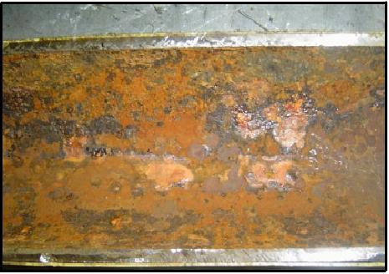

**Figure 1.** Internal corrosion of water injection pipeline.

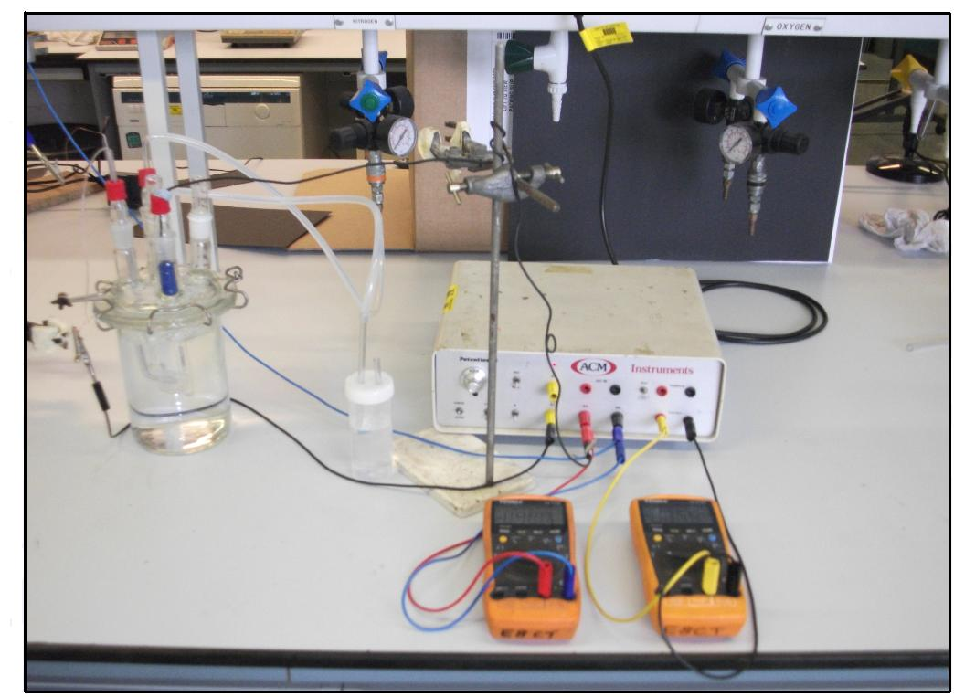

**Figure 2.** Electrochemical cell during deaerated process at -200 mV SCE.

**Table 2.** Corrosion rate of the water injection system during operation of

the vacuum deoxygenation tower.

|  |  |  |  |  |  |  |  |  |  |  |
| --- | --- | --- | --- | --- | --- | --- | --- | --- | --- | --- |
|  | CR | | | | | | | | | |
| At 20 °C | | | | | At 40 °C | | | | |
| Inside diameter (in.) | | | | | Inside diameter (in.) | | | | |
| Parameter | 6 | 8 | 16 | 18 | 28 | 6 | 8 | 16 | 18 | 28 |
| CO2 (ppm) | 9.1 | 9.1 | 9.1 | 9.1 | 9.1 | 6.2 | 6.2 | 6.2 | 6.2 | 6.2 |
| (ppm) | 0.5 | 0.5 | 0.5 | 0.5 | 0.5 | 0.5 | 0.5 | 0.5 | 0.5 | 0.5 |
| CR (mm/yr) | 0.18 | 0.13 | 0.37 | 0.46 | 0.67 | 0.38 | 0.84 | 0.84 | 1 | 1.5 |

**Table 3.** Corrosion rate of the water injection system equipments during

Maintenance.

|  |  |  |  |  |  |  |  |  |  |  |
| --- | --- | --- | --- | --- | --- | --- | --- | --- | --- | --- |
|  | CR | | | | | | | | | |
| At 20 °C | | | | | At 40 °C | | | | |
| Inside diameter (in.) | | | | | Inside diameter (in.) | | | | |
| Parameter | 6 | 8 | 16 | 18 | 28 | 6 | 8 | 16 | 18 | 28 |
| Flow rate  (m3/hr) | 33 | 150 | 650 | 1075 | 4200 | 33 | 150 | 650 | 1075 | 4200 |
| Area of a pipe (m2) Eq.(9) | 0.0182 | 0.032 | 0.13 | 0.164 | 0.397 | 0.0182 | 0.032 | 0.13 | 0.164 | 0.397 |
| (m/s) Eq.(8) | 0.503 | 1.3 | 1.39 | 1.82 | 2.94 | 0.503 | 1.3 | 1.39 | 1.82 | 2.94 |
| CO2(ppm) | 9.1 | 9.1 | 9.1 | 9.1 | 9.1 | 6.2 | 6.2 | 6.2 | 6.2 | 6.2 |
| mol/m3 | 0.284 | 0.284 | 0.284 | 0.284 | 0.284 | 0.1937 | 0.1937 | 0.1937 | 0.1937 | 0.1937 |
| (m2/s) | 1.8E-9 | 1.8E-9 | 1.8E-9 | 1.8E-9 | 1.8E-9 | 3.7E-9 | 3.7E-9 | 3.7E-9 | 3.7E-9 | 3.7E-9 |
| (m2/s) | 1.0E-6 | 1.0E-6 | 1.0E-6 | 1.0E-6 | 1.0E-6 | 6.6E-7 | 6.6E-7 | 6.6E-7 | 6.6E-7 | 6.6E-7 |
| Re | 76428 | 263369 | 563206 | 829615 | 2084674 | 116500 | 400242 | 855903 | 1264596 | 3168072 |
| (m/s) Eq.(7) | 2.5E-5 | 5.5E-5 | 5.3E-5 | 6.6E-5 | 9. 6E-5 | 5.5E-5 | 1.2E-4 | 1.2E-4 | 1. 5E-4 | 2. 1E-4 |
| Eq.(10) | 2.74 | 6.0 | 5.81 | 7.24 | 10.52 | 4.11 | 9.0 | 8.97 | 11.21 | 15.95 |
| CR(mm/yr)Eq.(11) | 3.2 | 7 | 6.7 | 8.4 | 12.2 | 4.8 | 10.42 | 10.4 | 13 | 18.5 |
| CR  (mm/month) | 0.265 | 0.6 | 0.56 | 0.7 | 1.0 | 0.4 | 0.87 | 0.86 | 1.1 | 1.54 |

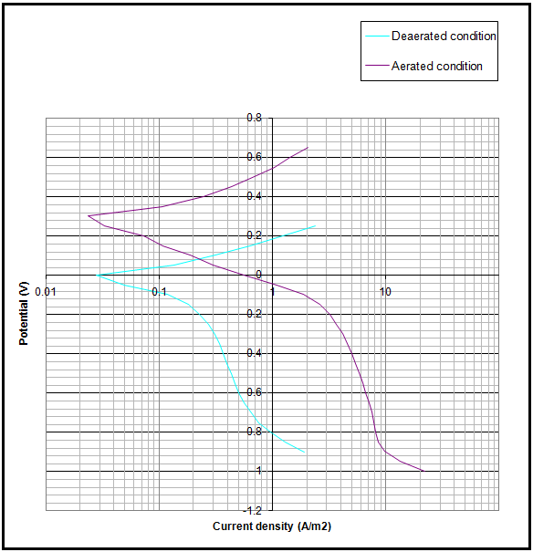

**Figure 3.** Polarization curve of platinum in solution of sodium chloride.

**Table 4.** Corrosion rate of the water injection system equipments after increasing the amount of the O2 scavengers

|  |  |  |  |  |  |  |  |  |  |  |  |
| --- | --- | --- | --- | --- | --- | --- | --- | --- | --- | --- | --- |
|  | CR | | | | | | | | | | |
| At 20 °C | | | | | | At 40 °C | | | | |
| Inside diameter (in.) | | | | | | Inside diameter (in.) | | | | |
| Parameter | 6 | 8 | 16 | | 18 | 28 | 6 | 8 | 16 | 18 | 28 |
| Flow rate  (m3/hr) | 33 | 150 | 650 | | 1075 | 4200 | 33 | 150 | 650 | 1075 | 4200 |
| Area of a pipe (m2) Eq.(9) | 0.0182 | 0.032 | 0.13 | | 0.164 | 0.397 | 0.0182 | 0.032 | 0.13 | 0.164 | 0.397 |
| (m/s) Eq.(8) | 0.503 | 1.3 | 1.39 | | 1.82 | 2.94 | 0.503 | 1.3 | 1.39 | 1.82 | 2.94 |
| CO2(ppm) | 0.01 | 0.01 | 0.01 | | 0.01 | 0.01 | 0.01 | 0.01 | 0.01 | 0.01 | 0.01 |
| mol/m3 | 3.1E-4 | 3.1E-4 | | 3.1E-4 | 3.1E-4 | 3.1E-4 | 3.1E-4 | 3.1E-4 | 3.1E-4 | 3.1E-4 | 3.1E-4 |
| (m2/s) | 1.8E-9 | 1.8E-9 | 1.8E-9 | | 1.8E-9 | 1.8E-9 | 3.7E-9 | 3.7E-9 | 3.7E-9 | 3.7E-9 | 3.7E-9 |
| (m2/s) | 1.0E-6 | 1.0E-6 | 1.0E-6 | | 1.0E-6 | 1.0E-6 | 6.6E-7 | 6.6E-7 | 6.6E-7 | 6.6E-7 | 6.6E-7 |
| Re | 76428 | 263369 | 563206 | | 829615 | 2084674 | 116500 | 400242 | 855903 | 1264596 | 3168072 |
| (m/s) Eq.(7) | 2.5E-5 | 5.5E-5 | 5.3E-5 | | 6.6E-5 | 9. 6E-5 | 5.5E-5 | 1.2E-4 | 1.2E-4 | 1. 5E-4 | 2. 1E-4 |
| Eq.(10) | 3E-3 | 6.6E-3 | 6.3E-3 | | 7.9E-3 | 1.15E-2 | 6.6E-3 | 1.4E-2 | 1.4E-2 | 1.79E-2 | 2.5E-2 |
| CR(mm/yr)Eq.(11) | 3.4E-3 | 7.6E-3 | 7.3E-3 | | 9.1E-3 | 1.3E-2 | 7.6E-3 | 1.6E-2 | 1.6E-2 | 2E-2 | 2.9E-2 |

Diffusivity coefficient of O2 in the water at 20°C and at 40°C are obtained from Coulson et **al.,1999, Verhallen et al.,1984.**

Kinematic viscosities of water at 20°C and 40°C are obtained from, **Josepn et al.,1987**.