GNSS Baseline Configuration Based on First Order Design
Muayed Yaseen Ahmed
Assistant professor
College of Engineering-University of Baghdad

Oday Yaseen Mohamed
Lecturer
College of Engineering-University of Baghdad
oday_alhamadani@hotmail.com

Zahraa Azeldeen Husain
Engineer
College of Engineering-University of Baghdad
Zahraaazeldeen@yahoo.com

ABSTRACT
The quality of Global Navigation Satellite Systems (GNSS) networks are considerably influenced by the configuration of the observed baselines. Where, this study aims to find an optimal configuration for GNSS baselines in terms of the number and distribution of baselines to improve the quality criteria of the GNSS networks. First order design problem (FOD) was applied in this research to optimize GNSS network baselines configuration, and based on sequential adjustment method to solve its objective functions.
FOD for optimum precision (FOD-p) was the proposed model which based on the design criteria of A-optimality and E-optimality. These design criteria were selected as objective functions of precision, which lead to a homogenous and anisotropic network, respectively using Matlab programming language (V. 2012a). Al Ghammas Township, Al-Qadisiya city, which consists of twenty-five stations was taken as a study area in this research.
The results showed that there are 300 potential baselines for the GNSS network of the study area, which were reduced during the optimum configuration to about 70% of the total potential baselines by applying FOD-p, and there is high level of improvement in the objective functions of precision which reached to about 90% .
Key Words: configuration baselines, FOD, GNSS network, A-optimality, E-optimality

تشكيل خط اساس الـ GNSS اعتمادا على مسألة التصميم من الرتبة الاولى
عدي ياسين محمد
مدرس
كلية الهندسة- جامعة بغداد
زهراء عزالدين حسين
مهندس
كلية الهندسة- جامعة بغداد
مؤيد ياسين احمد
أستاذ مساعد
كلية الهندسة- جامعة بغداد

الخلاصة
تتأثر جودة شبكات الانظمة العالمية للتوابع الملاحية (GNSS) بشكل كبير بتشكّيل خطوط الاساس المرصودة. حيث هذه الدراسة تهدف الى ايجاد التشكيل الأمثل لخطوط اساس الـ GNSS من حيث عددها وتوزيعها لتحسين معايير جودة شبكات الـ GNSS. أسلوب التصميم من المرتبة الاولى ومختصره (FOD) تم تطبيقه في هذا البحث للحصول على افضل تشكيل لخطوط الاساس الـ GNSS واعتمادا على اسلوب التصحيح المتعاقب لحل دوال اهدافها.
FOD للدقة المثلى (FOD-p) هو النموذج المقترح الذي اعتمد على معياري التصميم كل من A-optimality و E-optimality. هذة المعياران تم اختيارهما كدوال هدف للدقة والتي تؤدي الى تجانس وتوحيد خواص الشبكة على التوالي باستخدام لغة البرمجة MATLAB (V.2012a). حيث بلدة الغماس، مدينة القادسية والتي تتالف من 25 محطة تم اعتبارها كمنطقة دراسة لتطبيق النموذج المقترح في هذا البحث.
أضهرت النتائج هناك 300 خط اساس محتمل لشبكة ال GNSS لمنطقة الدراسة والذي تم تخفيضها لحوالي 70٪ من المجموع الكلي من خلال تطبيق موديل الـ FOD-p وان هناك مستوى عالي لتحسن دوال الهدف للدقة تصل الى حوالي 90%.

1. INTRODUCTION
Global Navigation Satellite System networks (G-net), referred as hereafter as applied for different kinds of surveys, such as topographic surveys, construction surveys and deformation and long-term monitoring surveys.
Furthermore, a geodetic network is defined as being any geometric configuration of three or more terrestrial survey points that are connected either by geodetic traditional observations made among them, such as directions and distance, and/or by astronomical measurements or space techniques: for instance, the global navigation satellite system(GNSS), Andreea, 2011.
Optimal design of a geodetic network is an important subject in many geodetic applications particularly, those which necessitates high level of precision consistency and homogeneity. The quality of a geodetic network, which sometimes referred to design criteria is characterized by its precision, reliability, and cost, Amiri, 2004. The precision of GNSS network can be expressed by the covariance matrix of the parameters (unknown coordinates). The optimization problems of geodetic networks are classified into zero order design problem (ZOD), first order design problem (FOD), second order design problem (SOD), and Third order design problem (THOD). As far as, the ZOD is defined as a search for an optimal datum, whereas the FOD is defined as the determination of an optimal configuration for the network. Regarding the SOD is defined as weight problem, and finally, the THOD is the optimal improvement of an existing network, Grafarend, et al., 1985.
In this research, optimization of a GNSS network is investigated based on selecting baseline vectors, which have maximum effect on design criteria, from all the probable baseline vectors that can be measured in a GNSS network. This configuration of baseline vectors, in terms of their number and their distribution between stations, is applied based on first order design Curran, 2008.

2. PREPARATIONS FOR G-NET DESIGN
There are various types of sources which are providing the approximate positions for the network stations, such as, aerial and satellite images, topographic maps, open sources like Google Earth and Google map, and GPS navigator. For designing the conventional geodetic networks, the visibility and the distances between the (adjacent) stations represent the most important factors in the designing stage. On the contrary, there is no need for station visibilities for GNSS networks. While, the baselines lengths represents one of the obstacles in the design of the G-net due to the reason that the baseline's precision depends on the configuration of the GNSS satellite constellation Zilkoski, and Hothem, 1989.
The field reconnaissance has to be carried out firstly for the purpose of optimum selection for G-net stations sites. This requires careful survey of the surrounding areas to the stations sites, e.g. avoiding reflective objects and surfaces which cause multipath of signals. Additionally, avoid buildings, bridges, structures, mountains, trees, etc. to prevent the cycle-slip which cause obstructions of the satellite signal. For further information about the design specifications for network stations sites, the reader can refer to Boal, 1992.
After the design of the G-net stations sites is accomplished, certain specifications for field crews can be written. These specifications should include the method of observation that agrees with the requirements of the accuracy, number of GNSS receivers, maximum baseline length, and other items. When approximate station coordinates are determined, a stochastic model for the observational system can be estimated for the baseline vectors, which be calculated by differencing the approximate coordinates for adjacent stations, Groten, et al., 1988.

2.1 Baselines (Vectors)
After fixing the positions of G-net stations in design stage, the designer must determine the minimum number and maximum number of potential baselines before selecting the optimal baseline configuration. Where, the minimum number of baselines depends on the minimum number of sessions. The latter is defined as a period of time, which two or more receivers are simultaneously recording satellite signal, Seeber, 2003. Simple mathematical relationships is considered in this research to fix both of the number of sessions and the number of baselines based on both of the number of stations of G-net and the number of available GNSS receivers, Dare, and Saleh, 2000. The minimum number of the sessions, which is referred to by "se", is calculated as follow:

$se = (ns- m) /(nr-m)$ (1)

where:
$nr$stands for the number of available GNSS receivers,
$ns$represents the number of stations, and
$m$ is the number of common stations between two sessions.
The number of minimum baselines, which is referred to by "$b_{min}$" is calculated as follow:

$b_{min} =(nr-1)×se+1$ (2)

While, the maximum number of baselines, which is referred to by "$b_{max}$" is calculated as follow:

$b_{max}=\left(ns-1\right)+\left(ns-2\right)+\left(ns-3\right)…+1$ (3)

2.2 Redundancy
To distinguish and isolate outliers and systematic errors from the G-net in general, the observations designed with sufficient redundancy. The redundancy of G-net is carried out by connecting each station with at least two independent baselines, Teunissen, and Kleusberg, 1998. The adequacy of redundancy must be taken into account by the designer when configuring baselines, Burfield, 2012.

3. A PRIORI LEAST SQUARES ADJUSTMENT OF GEODETIC NETWORKS
A pre-analysis of the network is an a priori adjustment of a network. It enables a surveyor to design the network before performing any actual observations in the field, whether the possibility exists that the quality specifications needed by the customer can be met. The combination of a stochastic and a functional model of the network are applied to estimate prior quality quantities, see Fig.1. These quantities are independent of the values of the actual observations and depend on the location of the stations, the observation scheme (the geometrical connections in the network), and on a priori assumptions about the expected precision of the observations. The latter is usually determined and claimed by the manufactures of the instruments, or can be estimated according to previous observations under similar conditions, Koch, 1977 and Staudinger, 1999.
The means of a stochastic model is defined as the random effects of the observations, which include the determination of variances and covariance and subsequently the weights of the observations during the least squares adjustment. The variance is a parameter which measures the spread of the probability density of a random variable, whereas the statistic relationship between two random variables is described by the covariance, Krakiwsky, 1999.

3.1 Least Squares Adjustment of G-net
As noted earlier, because of the G-net contains redundant observations which they must be adjusted to make all coordinate differences consistent. By applying least square adjustment to the problem of adjusting baselines in G-net networks, observation equations are written in a way to relate station coordinates to the observed coordinate differences and their residual errors. Coefficient matrix of G-net observation equation is similar to that in differential leveling .Fig. 2 illustrates this procedure, Ghilani, and Wolf, 2007.
Observation equation for baseline IJ:

$X_{J} = X_{I} + {∆X}_{IJ} + {VX}_{IJ}$ (4)

$Y_{J}= Y_{I} + {∆Y}_{IJ} + {VY}_{IJ}$ (5)
$Z_{J} = Z_{I} + {∆Z}_{IJ} + {VZ}_{IJ}$ (6)

4. ELLIPSOID OF ERROR
The ellipsoid of error can be computed based on eigenvalues and eigenvectors. In the case of three-dimensional matrix, the solution is carried out based on solving an equation of the third order which in turn leads to produce three eigenvalues $λ_{1},λ_{2},λ_{3}$. To explain how this procedure can be achieved, the variance matrix for one point will be explained as follows, AL-Joboori, 2010 and Junhuan, 2005.

$Q_{xx}= \left[\begin{matrix}σ_{x}^{2} & σ_{xy} & σ_{xz} \\ σ_{xy} & σ_{y}^{2} & σ_{yz} \\ σ_{xz} & σ_{yz} & σ_{z}^{2}\end{matrix}\right]$ (7)

Then the eigenvalues can be use in formula of$det(Q_{xx}-λI)=0$, and this yields:

$det\left|\begin{matrix}σ_{x}^{2}-λ & σ_{xy} & σ_{xz} \\ σ_{xy} & σ_{y}^{2}-λ & σ_{yz} \\ σ_{xz} & σ_{yz} & σ_{z}^{2}-λ\end{matrix}\right|=0$ (8)

After finding the eigenvalues, the three axes of ellipsoid are computed, and then the orientation angles are computed based on the computation of eigenvector $u_{1},u_{2},u_{3},$ as follow:
$\left[\begin{matrix}u_{1} \\ u_{2} \\ u_{3}\end{matrix}\right]=\left[\begin{matrix} (σ_{y}^{2}- λ)(σ_{z}^{2}- λ) - {(σ_{yz})}^{2} \\ σ_{xz}σ_{yz} - σ_{xy}(σ_{z}^{2}- λ) \\ (σ_{z}^{2}- λ) σ_{xz} - σ_{xy}σ_{yz}\end{matrix}\right]$ (9)

Finally, the orientation angles of each axis in ellipsoid are computed as follow:

$aλ =\tan^{-1}(u_{1} / u_{2})$ (10)
$vλ= \tan^{-1}(u_{3} / \sqrt{(u_{12}+u_{22})})$ (11)

Where $aλ$ and $vλ$ refer to the horizontal and vertical rotations consecutively as shown in Fig. 3.

5. AREA OF STUDY
Network of Al Ghammas Township, Al-Qadisiya city, was chosen as the area of study to design the G-net. The dimensions of this network are around 5 km in North-South direction and 4 km in the East-West direction, and the network consists of 25 stations as shown in Fig.4. The initial geocentric coordinates (X Y Z) _{WGS84} of the G-net stations are listed in Table 1. Fig.4 shows that the locations of twenty-five G-net stations for the area of study were distributed irregularly and this yielded irregular geometric shapes.

6. FOD FOR OPTIMUM PRECISION (FOD-p)
In the application of FOD-p, it was aimed to constitute a homogeneous and isotropic network. For that reason, an A-optimality solution ($trace (Q_{xx}) → min$) that leads to a homogeneous network and an E-optimality solution ($λ_{max}→ min$) that leads to an isotropic network were selected as objective functions. Through FOD-p code application in this research, the initial scheme of G-net observations was determined firstly, and then the axes of ellipsoid errors and the resultant of axes of ellipsoid, which defined as helmert errors (HPE), were computed. HPE was used to distinguish between stations which have maximum level of error than the stations which have minimum level of error. The objective functions were improved (minimize) by adding new baselines which have maximum effect on both objective functions. In FOD-p code of this research, the baseline that connects between two stations of maximum and minimum error was found a significant effect on the objective function, and was added firstly. One of the most important finding in this research that when the changes in the both of the objective functions have a few impact on improving precision, this refers to obtain the optimum precision in terms of a homogeneity and isotropy for all stations.

6.1 FOD -p for the Area of Study (Al-Ghammas Township)
The effect of adding new baselines on the values of objective functions of precision, which represented by A-optimality and E-optimality is shown in Table 2 and in Fig 5.
The values of objective functions for both of A-optimality and E-optimality were reduced by around 90%, which yielded from adding baseline that have maximum effect on minimizing objective functions of precision.
The values for both of axes of ellipsoid error and helmert point error for the twenty-five stations in the initial and final scheme are listed in Table 3.
GNSS baselines configuration was started from the first scheme to reach optimal precision of G-net in seventeenth scheme as in Fig 6 (a-b).

7. CONCLUSIONS
This research showed that the optimal configuration of GNSS baselines can be carried out effectively based on the first order design (FOD) with sequential adjustment solution technique to improve the quality criteria of GNSS network in terms of precision.
FOD-p model, which based on minimizing both of A-optimality and E-optimality as objective functions, was achieved to gain the best possible precision of the G-net in terms of decreasing errors, improving homogeneity, and enhancing isotropy.
In the initial scheme of G-net for the area of study, the stations which are located around the center of the network have minimum ellipsoid errors due to their adequacy of observations. Unlike the stations which are located on the perimeter of the network have maximum ellipsoid error due to their inadequacy of observations.

REFERENCES
- AL-Joboori, B. S., 2010, Adjustment in Surveying: Theory and Practice, University of Baghdad, College of Engineering, Iraq, in Arabic.

- Amiri-Simkooei, A., and Sharifi, M. 2004, Approach for Equivalent Accuracy Design of Different Types of Observations, Journal of Surveying Engineering, 130(1), 1-5

- Andreea, B. U. 2011, Considerations on The Development of Geodetic Network by Classical and GPS Methods, Agriculture, agricultural practice and science journal, 77, 230-234.

- Boal, J. D., 1992, Guidelines and Specifications for GPS Surveys, Geodetic Survey Division, Canada.

- Curran, L. P., 2008, Global Navigation Satellite Systems for Geodetic Network Surveys.

- Dare, P., and Saleh, H., 2000, GPS Network Design: Logistics Solution Using Optimal and Near-Optimal Methods, Journal of Geodesy, 74(6), 467-478.

- Ghilani, C. D., and Wolf, P. R., 2007, Principles of Least Square, In Adjustment Computations (pp. 173-204): John Wiley & Sons, Inc.

- Grafarend, E. W., Sansò, F., and Benciolini, B., 1985, Optimization and Design of Geodetic Networks, Springer-Verlag Berlin, Heidelberg, New York, Tokyo.

- Groten, E., Blewitt, G., Melbourne, W. G., Bertiger, W. I., Dixon, T. H., Kroger, P. M., et al., 1988, GPS Geodesy with Centimeter Accuracy, In GPS-Techniques Applied to Geodesy and Surveying, 19, 30-40: Springer Berlin Heidelberg.

- Junhuan, P., 2005, The Asymptotic Variance-Covariance Matrix, Baarda Test and The Reliability of L- Norm Estimates, Journal of Geodesy, 78(11), 668-682.

- Koch, K. R., 1977, Least Squares Adjustment and Collocation, Bulletin géodésique, 51(2), 127-135.

- Krakiwsky, E. J., and University of New Brunswick. Dept. of Geodesy and Geomatics, E., 1999, Development and Testing of In-Context Confidence Regions for Geodetic Survey Networks, Fredericton: Department of Geodesy and Geomatics Engineering, University of New Brunswick.

- Seeber, G., 2003, Satellite Geodesy, Walter de Gruyter. Berlin .New .York.

- Staudinger, M., 1999, A Cost Orientated Approach to Geodetic Network Optimisation, Vienna University of Technology.

- Teunissen, P. J. G., Kleusberg, A., 1998, GPS for Geodesy, 2: Springer Berlin.

- Zilkoski, D., and Hothem, L., 1989, GPS Satellite Surveys and Vertical Control, Journal of Surveying Engineering, 115, 262-281.

LIST OF SYMBOLS

Symbol | Description
$$σ_{0}^{2}$$ | variance of unit weight, cm².
$$σ$$ | standard deviation, cm.
$$σ_{x},σ_{y} σ_{z}$$ | standard deviation of coordinates, cm.
$$v$$ | vector of residuals, m.
$$Q_{xx}$$ | cofactor matrix of the unknown parameters, cm.
$$n$$ | no. of observations, dimensionless.
$$u$$ | no. of unknowns, dimensionless.
$$ג_{1},ג_{2},ג_{3}$$ | eigenvalues, dimensionless .
$$u_{1},u_{2},u_{3}$$ | eigenvector, dimensionless .
$$∆X, ∆Y, ∆Z$$ | baseline vectors, m.
$$se$$ | the number of sessions, dimensionless.
$$bi$$ | the number of baselines, dimensionless.
$$nr$$ | the number of receivers, dimensionless.
$$ns$$ | the number of stations, dimensionless.
$$m$$ | the number of common stations between two sessions, dimensionless.

Table 1. The initial geocentric coordinates (WGS84) of the area of study.
Stations | X (m) | Y(m) | Z (m)
S₁ | 3863932.02 | 3812639.41 | 3337605.20
S₂ | 3863929.35 | 3812863.89 | 3337351.68
S₃ | 3864422.90 | 3812938.49 | 3336699.54
S₄ | 3864331.45 | 3813222.93 | 3336468.69
S₅ | 3864639.19 | 3813104.62 | 3336249.46
S₆ | 3864534.58 | 3813404.50 | 3336027.52
S₇ | 3864934.71 | 3812730.31 | 3336335.47

Table 1. The initial geocentric coordinates (WGS84) of the area of study.
Stations | X (m) | Y(m) | Z (m)
S₈ | 3864698.04 | 3813522.68 | 3335705.08
S₉ | 3865053.31 | 3812752.69 | 3336174.64
S₁₀ | 3864843.58 | 3813578.41 | 3335475.65
S₁₁ | 3865106.50 | 3813058.98 | 3335763.92
S₁₂ | 3865232.06 | 3813337.94 | 3335302.98
S₁₃ | 3865340.59 | 3812654.95 | 3335955.25
S₁₄ | 3865547.80 | 3812950.91 | 3335378.68
S₁₅ | 3865510.76 | 3812391.52 | 3336057.04
S₁₆ | 3865790.59 | 3812977.65 | 3335068.27
S₁₇ | 3865766.37 | 3812493.04 | 3335648.49
S₁₈ | 3865866.43 | 3813009.20 | 3334944.97
S₁₉ | 3865806.74 | 3812155.22 | 3335995.09
S₂₀ | 3866064.18 | 3813190.00 | 3334512.87
S₂₁ | 3866110.76 | 3812226.29 | 3335565.21
S₂₂ | 3866169.49 | 3812645.35 | 3335022.65
S₂₃ | 3866503.44 | 3812211.55 | 3335130.17
S₂₄ | 3866771.75 | 3812282.55 | 3334740.57
S₂₅ | 3867284.47 | 3812268.06 | 3334166.09

Table 2.Improved objective functions of FOD-p by adding baselines.
No. iteration | No. Baselines | A- optimality | E- optimality
1 | 47 | 19.96 | 1.01
2 | 49 | 11.04 | 0.40
3 | 51 | 9.00 | 0.29
4 | 53 | 7.51 | 0.25
5 | 55 | 6.30 | 0.22
6 | 57 | 5.55 | 0.19
7 | 59 | 5.21 | 0.18
8 | 61 | 4.63 | 0.16
9 | 63 | 4.08 | 0.14
10 | 65 | 3.73 | 0.13
11 | 67 | 3.39 | 0.12
12 | 69 | 3.14 | 0.12
13 | 71 | 2.98 | 0.11
14 | 73 | 2.81 | 0.10
15 | 75 | 2.61 | 0.09
16 | 77 | 2.42 | 0.08
17 | 78 | 2.41 | 0.08

Table 3.The results of FOD-p model for the area of study.
Stations | a  Semi-Axis Ellipsoid,cm |  | b  Semi-Axis Ellipsoid,cm |  | c  Semi-Axis Ellipsoid,cm |  | Helmert Point Errors,cm
 | Initial | Final | Initial | Final | Initial | Final | Initial | Final
1 | 4.81 | 1.19 | 5.07 | 1.25 | 10.03 | 2.48 | 12.23 | 3.02
2 | 4.45 | 1.11 | 4.69 | 1.17 | 9.28 | 2.31 | 11.31 | 2.81
3 | 4.17 | 1.11 | 4.39 | 1.17 | 8.69 | 2.32 | 10.60 | 2.83
4 | 3.92 | 1.33 | 4.13 | 1.41 | 8.17 | 2.78 | 9.96 | 3.39
5 | 3.68 | 1.14 | 3.88 | 1.20 | 7.67 | 2.38 | 9.35 | 2.90
6 | 3.45 | 1.12 | 3.64 | 1.18 | 7.20 | 2.34 | 8.78 | 2.85
7 | 3.25 | 1.22 | 3.42 | 1.29 | 6.77 | 2.54 | 8.25 | 3.10
8 | 3.06 | 1.24 | 3.23 | 1.30 | 6.39 | 2.58 | 7.78 | 3.14
9 | 2.90 | 1.23 | 3.06 | 1.30 | 6.05 | 2.57 | 7.37 | 3.14
10 | 2.77 | 1.35 | 2.92 | 1.42 | 5.78 | 2.81 | 7.04 | 3.42
11 | 2.67 | 1.35 | 2.82 | 1.42 | 5.57 | 2.81 | 6.79 | 3.43
12 | 2.61 | 1.22 | 2.75 | 1.29 | 5.45 | 2.54 | 6.64 | 3.10
13 | 2.59 | 1.22 | 2.73 | 1.29 | 5.40 | 2.55 | 6.59 | 3.10
14 | 2.61 | 1.21 | 2.75 | 1.28 | 5.45 | 2.53 | 6.64 | 3.08
15 | 2.67 | 1.34 | 2.82 | 1.41 | 5.57 | 2.79 | 6.79 | 3.40
16 | 2.77 | 1.11 | 2.92 | 1.17 | 5.78 | 2.32 | 7.04 | 2.83
17 | 2.90 | 1.35 | 3.06 | 1.42 | 6.05 | 2.81 | 7.37 | 3.42
18 | 3.06 | 1.22 | 3.23 | 1.29 | 6.39 | 2.55 | 7.78 | 3.11
19 | 3.25 | 1.24 | 3.42 | 1.30 | 6.77 | 2.58 | 8.25 | 3.14
20 | 3.45 | 1.13 | 3.64 | 1.19 | 7.20 | 2.35 | 8.78 | 2.87
21 | 3.68 | 1.11 | 3.88 | 1.17 | 7.67 | 2.32 | 9.35 | 2.83
22 | 3.92 | 1.13 | 4.13 | 1.19 | 8.17 | 2.35 | 9.96 | 2.87
23 | 4.17 | 1.11 | 4.39 | 1.17 | 8.69 | 2.31 | 10.60 | 2.81
24 | 4.45 | 1.11 | 4.69 | 1.17 | 9.28 | 2.32 | 11.31 | 2.82
25 | 4.81 | 1.10 | 5.07 | 1.16 | 10.03 | 2.29 | 12.23 | 2.79

Expected Variance
of Observations
Estimated
Observations
Stochastic
Model
Functional
Model
Initial of Parameters
A priori Least
Squares
Adjustment
Adjusted
Parameters
Expected Variance of
Adjusted Parameters

Figure 1.The main stages of least square adjustment, Staudinger, 1999.

J
$$Y$$
I
$$∆X$$
$$∆Y$$
$$∆Z$$
$$X$$
$$Z$$
Baseline

Figure 2. Baseline vectors of GNSS network, Ghilani and Wolf, 2007.

$$aλ$$
$$Y$$
$$λ_{1}$$
$$λ_{2}$$
$$λ_{3}$$
$$X$$
$$Z$$
$$vλ$$

Figure 3. Ellipsoid of error.

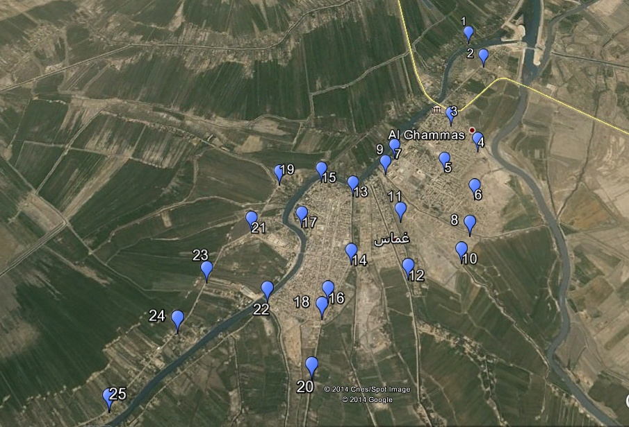
Figure 4. The area of study, Al Ghammas township, Al-Qadisiya city.

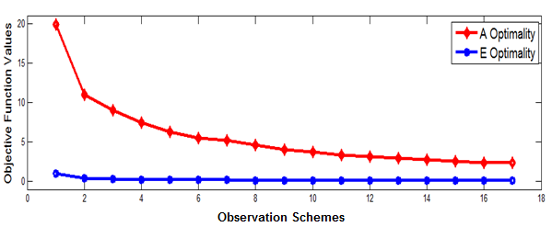
Figure 5. The improvement of the objective functions over 17 schemes.

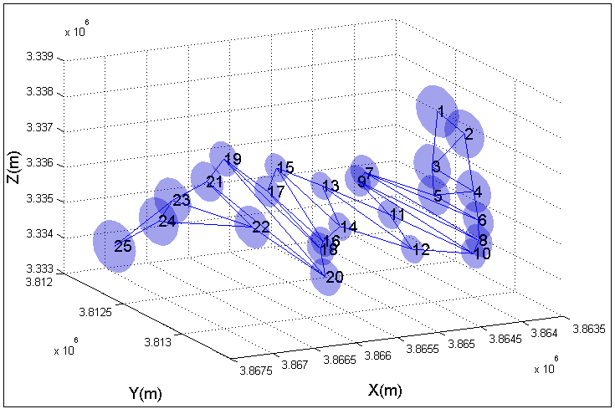
(a) The First Observation Scheme
Figure 6. Observation schemes of FOD-p model for the area of study.

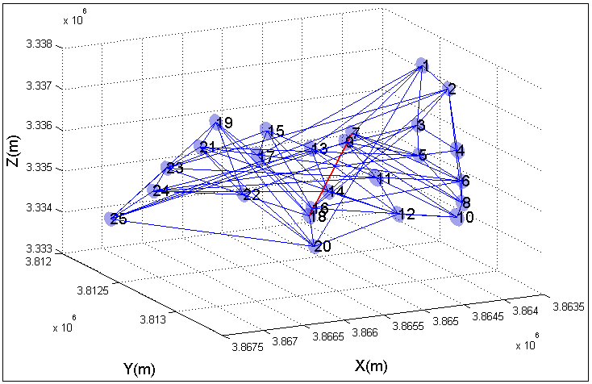
(b) The Final (Seventeenth) Observation Scheme
Figure 6. Observation schemes of FOD-p model for the area of study.

