**Reinforcement of Asphalt Concrete by Polyester Fibers to Improve Flexural Bending Fatigue Resistance**

|  |  |
| --- | --- |
| **Dr. Mohammed Qadir Ismael**  Instructor  University of Baghdad-Civil Engineering Dept.  [drmohammedalbayati@gmail.com](mailto:drmohammedalbayati@gmail.com) | **Hiba M. Al-Taher**  M.Sc. Student  University of Baghdad-Civil Engineering Dept.  hibamalik1986@yahoo.com |

**ABSTRACT**

**R**einforcing asphalt concrete with polyester fibers considered as an active remedy to alleviate the harmful impact of fatigue deterioration. This study covers the investigation of utilizing two shapes of fibers size, 6.35 mm by 3.00 mm and 12.70 mm by 3.00 mm with mutual concentrations equal to 0.25 %, 0.50 % and 0.75 % by weight of mixture. Composition of asphalt mixture consists of different optimum (40-50) asphalt cement content, 12.50 mm nominal aggregate maximum size with limestone dust as a filler. Following the traditional asphalt cement and aggregate tests, three essential test were carried out on mixtures, namely: Marshall test (105 cylindrical specimens), indirect tensile strength test (21 cylindrical specimens) and flexural bending test (21 beam specimens). The results revealed that, more asphalt content needed as the fibers length and concentration increased. The fatigue life estimation depending on cyclic load to failure in the beam test support the idea that polyester fibers really improve the resistance of fatigue cracking since the repetitions to failure increased by 9.40 % for the 0.50 % of 12.70 mm fibers length. Both of Marshall stability and indirect tensile strength suffer from slight reduction in their values, whereas, the 0.75 % of 12.70 mm fibers length caused lowering in Marshall stability and indirect tensile strength by 11.70 % and 6.00 % respectively.

**Key words:** Asphalt Pavement, fatigue cracking, polyester fibers, beam test, tensile strength

**تعزيز الخرسانة الأسفلتية بالياف البوليستير لتحسين مقاومة الكلل لانحناء الثني**

|  |  |
| --- | --- |
| **هبة مالك الطاهر**  طالبة ماجستير  جامعة بغداد – قسم الهندسة المدنية | **د. محمد قادر اسماعيل**  مدرس  جامعة بغداد – قسم الهندسة المدنية |

**الخلاصة**

اعتبر تعزيز الخرسانة الاسفلتية بالياف البوليستير كعلاج فعال للتقليل من الاثر الضار لتدهور الكلل. يغطي هذا البحث التحقيق من استخدام شكلين من احجام الالياف, 6.35 مم *3.00 مم و 12.70مم*3.00مم وبنسب مشتركة تساوي 0.25%,0.50% و0.75% من وزن الخلطة.مكونات الخلطة الاسفلتية تتالف من محتوى امثل متعدد من السمنت الاسفلتي 40-50, 12.5مم من المقاس الاسمي الاقصى للركام مع غبار حجر الكلس كمادة مالئة. تبع اجراء الفحوص التقليدية للسمنت الاسفلتي والركام اجراء ثلاث فحوص رئيسة للخلطات واسمائها: فحص مارشال(105 عينة اسطوانية),فحص قوة الشد غير المباشر(21 عينة اسطوانية) وفحص انحناء الثني(21 عينة عتبة).اظهرت النتائج الحاجة الى المزيد من محتوى الاسفلت كلما زاد تركيز وطول الالياف. تقدير عمر الكلل اعتمادا على التحميل الدوري الى الفشل في فحص العتبة ساند فكرة ان الياف البوليستير فعلا تحسن مقاومة تشقق الكلل حيث ان التكررات للفشل زادت ب 9.40% ل 0.50% من الالياف بطول 12.70مم.كلا من ثبوتية مارشال وقوة الشد غير المباشر عانت من نقصان قليل لقيمهما, حيث, 0.75% من الالياف بطول 12.70مم سبب تخفيض لثبوتية مارشال و قوة الشد غير المباشر ب 11.70% و6.00% بالتعاقب.

**1. INTRODUCTION**

It is widely recognized that highways play an important role in economic and social development of societies, therefore, many studies are directed towards modifying pavement properties. In Iraq as well as other countries, pavement surface cracks are considered as a major problems affected the performance of road networks. In order to prevent the cracking progress of asphalt layer, numerous efforts are devoted to improve the performance of asphalt mixtures, hence, many additives are used for this purpose. Polyester fibers are incorporating in asphalt mixtures production to enhance the resistance of flexible pavement against fatigue cracking, **Abtahi, et al., 2010.**

Reinforcement generally includes addition of materials which have some desired properties to other materials which do not have these properties. Fibers reinforcement was used to carry the tensile loads, improve the pavement resistance to some distresses as well as to prevent the formation and propagation of cracks, **Mahrez and Karim, 2010.**

* 1. **Objective of the Study**

The main purpose of the effort presented in this study is to investigate the role of reinforcing the asphalt mixture by polyester fibers with different contents and sizes.The course of experimental workinvolved the conventional Marshall test properties and the ability of mixture to resist the tensile stress by conducting the indirect tensile strength test. The achievement of fatigue resistance will be accomplished by performing the flexural bending fatigue test on asphalt concrete beam specimens.

**2. REVIEW OF LITERATURES**

One of the most significant distress modes in flexible pavements is fatigue cracking. The action of repeated loading caused by traffic induces tensile and shear stresses in the bound layers which lead to the gradual loss in the structural integrity of the material. Fatigue initiates cracks in the wheel path at points where critical tensile strains and stresses occur. Once the damage initiates at the critical locations, the action of traffic eventually causes these cracks to propagate through the entire bound layer, **Al-Khateeb and Shenoy, 2011**.

**Moghaddam, et al., 2011**, depicted that fatigue resistance of asphalt mixture is its ability to withstand repeated bending without fracture. Most analyses utilize flexure stresses or strains on the underside of the asphalt concrete pavement layers to assess the fatigue life.

As cited by **Deacon, et al., 1994**, in the early 1960s, Monismith, et al., and Pell established the relationships between Hot Mixed Asphalt (HMA) fatigue life and horizontal tensile stress or tensile strain at the bottom asphalt layer by using the basic forms shown in Eqs. (1) and (2).

$N\text{f}\text{ = }\text{k}\text{1}{{\left[ \frac{1}{σ\text{t}} \right]}^{k\text{2}}}^{ }$ (1)

$N\text{f } \text{=}\text{ k}\text{3}{{\left[ \frac{1}{ε\text{t}} \right]}^{k\text{4}}}^{ }$ (2)

Where Nf is the number of repetitions to failure, σt is the magnitude of the tensile stress repeatedly applied, εt is the magnitude of the tensile strain repeatedly applied, and k1, k2, k3, and k4 are the experimentally determined coefficients.

An interesting statement declared by **Serfass and Samanos, 1996,** demonstrated that adding fibers enables developing asphalt mixtures that are rich in bitumen which create high resistance to ageing, effects of water and fatigue cracking as well as mechanically strong high resistance to shear, tension and flexure.

**Asmael, et al., 2010,** showed that polyester fibers do improve the performance of the asphalt mix as they enhance the stability, mainly due to their stabilizing and multi-directional reinforcing function. They also absorb the bitumen and thicken the bitumen film adhering to the aggregate, which strengthens the resistance of the asphalt mix to environmental disruption and water damage.

**Chen, et al., 2009,** used polyester fibers as the reinforcement for improving the fatigue life of asphalt mixture, by conducting the fatigue beam test on densely graded bitumen concrete, they concluded that, addition of the fibers decelerates the deflection development and crack evolution significantly for heavy loading road applications.

**Qunshan, et al., 2009,** used three types of fibers including polyester fibers, cellulose fibers and mineral fibers as modifiers for asphalt mixture with the dosage of 0.30 %, 0.35 % and 0.40 % by the total weight of asphalt mixture. The fatigue properties of asphalt mixture were studied at different stress ratios. Their extensive work showed that fatigue parameters of asphalt mixtures with fibers were decreased, which indicated that fatigue property could be improved by fibers modifiers.

**Xu, et al., 2010**, investigated the effect of polyester fibers with different percentages (0.00 %, 0.20 %, 0.35 % and 0.50 % by weight of mixture) on fatigue properties of asphalt concrete mixtures. Third-point bending fatigue test with stress controlled mode was performed at 20°C. They reported that addition of fibers into mixture resulted in increment of fatigue life. Consequently, fatigue life of AC with polyester fibers was more than other mixtures. As mentioned in their study, the improvement of fatigue characteristic is attributed to the three-dimensional networking effect of fibers in AC and stabilization of binder on surface of aggregate.

**Anurag, et al., 2009,** used roofing polyester waste fibers with two lengths (0.635 cm and 1.270 cm) and two contents (0.35 %, and 0.50 % by weight of total mixture). After conducted the indirect tensile strength test of asphalt concrete mixtures, they reported that addition of the polyester fibers was beneficial in improving the tensile strength properties in addition to increasing the following parameters; void content, asphalt content, unit weight, and Marshall stability, furthermore, they found that 0.635cm long fibers with 0.5 % content proved to be the best combination.

In another study performed by **Ye, et al., 2009**, which was carried out on fatigue properties of three types of fibers modified binder containing cellulose fibers, polyester fibers and mineral fibers. It was shown that fatigue parameters (dynamic modulus **|**E\***|** and phase angle (δ)) were decreased, so, the fatigue properties of fibers modified asphalt mixtures were improved compared to control mixture. Besides, the indirect tensile fatigue test (ITFT) was performed at different stress ratios, and the result illustrated that polyester fibers had the best influence on fatigue resistance of mixture among the three.

**Shaopeng, et al., 2008,** investigated the role of reinforcing asphalt mixture by polyester fibers, they depicted that viscosity of asphalt binder is increased with increasing polyester fibers contents and the cycle numbers to fatigue failure of fibers modified asphalt mixture are increased with 1.9, 2.9 and 3.6 times at 0.5, 0.4 and 0.3 stress ratios, besides, they found that optimum polyester fibers content was 0.30 % by weight of total mixture.

**Salman, et al., 2001,** investigated the effects of several types of fibers on the Marshall properties,they reported that adding such types of fibers to asphalt-mixture caused negative effects on variables of Marshall test (stability, flow, unit weight, air voids content , and voids in mineral aggregate). They also found that fibers-asphalt mixes required more compaction effort as compared to the control specimens.

**Hasan, 1997,** added three types of fibers to asphaltic mixture with lengths of (1.0 cm and 0.5 cm) and contents of (0.10, 0.20, 0.30, and 0.40) percentages by weight of total mixture. These fibers included Polypropylene fibers, Fibers Glass, and Steel wires. Marshall properties, indirect tensile strength, temperature susceptibility and resistance to moisture damage are studied. He found that optimum fibers content necessary to provide all the desired mixture properties has been determined to be equal to 0.20 % (by weight of total mixture) and the use of fibers with optimum asphalt content had improved performance related properties of paving mixtures including tensile strength, resistance to plastic flow and resistance to moisture damage.

**3. MATERIALS AND METHODS OF TESTING**

**3.1 Asphalt Mixtures Composition**

In general, the hot mix asphalt mixtures designed for this study are composed of aggregates (coarse, fine and mineral filler), asphalt binder and polyester fibers. Essentially, all the participated materials are locally available and traditionally utilized in paving process excluding the fibers. Several test were undertaken on asphalt binder and aggregates particles to satisfy the **SCRB R/9, 2003** requirements. **Tables 1, 2, 3** and **4** summarized the principal outcomes of the performed tests.

The prepared mixtures involved the following substances:

* 40-50 penetration grade of asphalt cement obtained from Daurah refinery,
* 12.5 mm nominal aggregate maximum size brought from Al-Nibaee quarry,
* Natural sand and limestone dust brought from Karbala province, and
* Sheets of Polyester fibers obtained from local market.

**3.1.1 Polyester Fibers**

The polyester fibers are spun bond, non-woven and continuous. This commercial product trim waste was obtained from the rolls of polyesters used for roofing. Based on previously mentioned literatures, the polyester fibers incorporated in the present work have two length sizes of 6.35 mm and 12.70 mm with one width size of 3.00 mm as shown in **Fig.1**. Implementation of these fibers sizes aided by using paper shredder machine. The content of these fibers has three percentages; 0.25 %, 0.50 % and 0.75 % by weight of mixture.

**3.2 Preparation of Asphalt Mixtures**

Following the operation of sieving, the aggregates recombined with appropriate proportions which is necessary to meet the range of gradation specified by **SCRB R/9, 2003** for the wearing course asphalt pavement as listed in **Table 5** and portrayed in **Fig.2**. Prior to conducting the I.T.S and fatigue tests, Marshall test method (**ASTM D-6927**) was carried out on cylindrical specimens (101.6 mm in diameter and 63.5 mm in height) with different asphalt content for control mixture (0.00 % fibers) and reinforced mixtures to gain the optimum asphalt content for each combination in order to prepare the mixtures for the remaining tests, 105 specimens have been prepared for this test and some of them are displayed in **Fig.3**.

The polyester fibers were mixed with aggregates thoroughly for 15-25 sec, the aggregate are then heated to a temperature of 155 °C before mixing with asphalt cement which has already been heated to a temperature that produce a kinematic viscosity of (170 ± 20) centistokes (up to 163 °C as an upper limit), then, the asphalt cement is weighed to the desired amount and added to the heated aggregates and mixed thoroughly until all aggregates and polyester fibers particles are coated with asphalt. The direct measurements from Marshall test are stability and flow values while the following properties are calculated depending on density - voids analysis:

 (3) VMA = 100 – [ GBM × PA / GBA ] (4)  (5)

where:

AV = percent of air voids by total mixture weight,

VMA = percent of voids in mineral aggregate,

VFA = percent of voids filled with asphalt,

GBM = bulk specific gravity of mixture,

GMM =theoretical maximum specific gravity of mixture,

PA = percent of aggregate by total weight of mixture, and

GBA = bulk specific gravity of aggregates.

**3.3 Indirect Tensile Strength Test**

This test was performed according to the method described in **ASTM D-6931.** The same Marshall mold dimensions have been utilized with total number equal to 21 specimens. They left to cool at room temperature for 24 hours and then placed in an air bath at 25 °C for 4 hours in order to bring them to test temperature. The loading strips were placed and the load was applied at a strain rate of 50 mm/min. Three specimens for each mix combination were tested and the average results were reported. The indirect tensile strength in kPa was then calculated as follows:

I.T.S. = 2000 Pult / π t D (6)

where

Pult = ultimate applied load required to fail the specimen, N

t = thickness of the specimen, mm

D = diameter of specimen, mm

**3.4 Preparation of the specimens for the flexural bending fatigue test**

The beam specimens have the dimensions of 500 mm in length, 100 mm in width and 50 mm in height and required approximately 5.750 kg of prepared asphalt mixture. The manufactured iron mold was heated to the compaction temperature. The mold and tamping foot were lightly oiled; 2 sheets of 10 cm by 50 cm papers placed on the mold base plate. The compactor foot was maintained sufficiently hot to prevent the mixture from adhering to it. One half of the required amount of mixture for one specimen was placed in the mold in a uniform layer, spade the mixture vigorously with a heated spatula or trowel 40 times around the perimeter of the rectangular and 27 times over the interior of the rectangular. The leveling plate was placed on top of the specimen. Using a compression testing machine, a static load of 45 kN was applied on the specimen at a rate of 0.50 mm /min. The other remaining quantity of asphalt material was added in the same procedure. Three beam specimens for each mix combination were tested and the average results were reported. **Fig.4** shows some of the 21 beams specimens formed for this test.

**3.5 Repeated loading apparatus**

This apparatus has the ability to apply repeated load with different pressure values and within various loading and testing periods, furthermore, the testing chamber can maintain the temperature at the desired heat condition, **Albayati, A. H., 2006**. Compressive loading was applied in the form of rectangular wave with a constant loading frequency of 120 cycles per minute including 0.1 sec loading time and 0.4 sec rest period. Application of 45 kPa stress level was utilized and the test was controlled at a temperature of 20 oC. In the fatigue test, the number of applications to failure (Nf) was counted. A third-point loading system was chosen due to the advantage of the constant bending moment existence over the specimen middle third, so that, any weak spot due to non-uniform material properties will show up in the test results as declared by **Huang, 2004.**The beam dimensions with applied load system is configured in **Fig.5** while the test running is shown in **Fig.6**.

**4. RESULTS AND DISCUSSION**

**4.1 Marshall test**

The effort spent in conducting Marshall test was essential to specify the optimum asphalt content for the various mixtures combinations, in this way, the control mixture (0.00 % fibers) witness the best results at 4.90 % of asphalt content (by weight of total mixture). However, this percent is slightly increased when fibers presented, whereas, for the 6.35 mm fibers size, the asphalt magnitudes become

5.00 %, 5.15 % and 5.30 % for the three proportions of fibers (0.25 %, 0.50 % and 0.75 % by weight of mixture) respectively. In the same manner, the asphalt values elevated to 5.10 %, 5.25 % and 5.40 % in the case of using 12.70 mm fibers size for the same proportions. The justification of this behavior belongs to the larger surface area of fibers which defiantly required more asphalt to coat. All the test results are listed in **Table 6** while **Fig.7** visualized only the attitude of control mixture. **Fig.8** displays the effect of fibers content on optimum asphalt content. As regard to stability values, specimens molded utilizing fibers exhibited lower stability with reductions values of 3.00 %, 5.00 % and 9.80 % for the first size (6.35 mm) and 4.00 %, 8.80 % and 11.70 % for the second size (12.70 mm) as shown in **Fig.9**, this might be explained by the increase in asphalt content which cause some sliding action for aggregate particles. The specimens containing no fibers had lower air void content than the mixtures containing polyester fibers, for further detailing, mixtures containing fibers length of 6.35 mm have higher air voids than the control mixture by 1.30 %, 9.40 % and 13.50 % for the three fibers content categories while specimens containing the other fibers size witness an growth in air voids by 8.10 %, 10.80 % and 14.80 % as portrayed in **Fig.10**. However, this behavior could be understood due to the low specific gravity of fibers which resulted in reducing the bulk density of mixture that leading to increase air voids.

**4.2 Effect of polyester fibers on I.T.S.**

The influence of reinforcing asphalt mixtures by polyester fibers on tensile strength is plotted in **Fig.11.** As can be seen, there is a little reduction in tensile strength value as the fibers acted. In other words, incorporating fibers with 6.35 mm length produce values of reduction of 3.40 %, 5.00 % and 5.60 %, while for the other fiber size, the reduction values increased to 4.10 %, 5.50 %, and 6.00 % for the three fibers contents. This could be due to their relatively higher air voids, i.e., higher air voids provide more space resulting in greater expanding forces.

**4.3 Effect of polyester fibers on flexural bending fatigue test**

Performing the flexural bending test on asphalt beam specimens at the specified conditions provides the results which are listed in **Table 7** and plotted in **Fig.12.** It seems to be that adding polyester fibers indeed show some enhancement in the fatigue properties. Demonstrating by percentages, 4.70 %, 8.10 % and 7.40 % growth of cyclic loads to failure occurred when the fibers of 6.35 mm length size presented in the mixtures with their three blended categories. Referring to the fibers of 12.70 mm length size, the same increase happened with little enlargement, in other words, 5.40 %, 9.40 % and 8.70 % percentages of increase observed. It is clearly noticed that 0.50 % of fibers content yields the best results for both fibers configuration. This improvement confirmed to the fact that the fibers distributed in different directions of asphalt-aggregates matrix causing high strain capacity of the mixes owing to their higher asphalt content and the thicker film coating the aggregates.

**5. CONCLUSIONS**

* The potential of reinforced asphalt concrete to withstand fatigue deterioration succeed to show through flexural bending test, whereas, the 0.50 % with 12.70 mm fibers length showed the higher percentage of enhancement by 9.40 %, on the other hand, the lowest increment of increase, 4.70 %, occurred by incorporating 0.25 % of 6.35 mm fibers length.
* It is appeared that, as the polyester fibers size and content increased, the required asphalt binder to produce the optimum Marshall properties increased also. Referring to this, reinforcing mixture by 0.25 % of 6.35 mm fiber length need 5.00 % of asphalt binder to reach the optimum behavior, while this percent become 5.40 % when the 0.75 % of 12.70 mm fiber length utilized.
* Within the limit of this study , continues rising of polyester length and contents seems to be slightly have an impairs effect on Marshall stability, herein, 0.25 % of first fibers size caused a reduction in Marshall stability by 3.00 %, unfortunately, this reduction elevated to 11.70 % as the 0.75 % of the second fibers size presented. However, all the reinforced specimens are still at safe distance from the minimum specification values.
* The specimens containing no fibers had lower air void content than the mixtures containing polyester fibers. Mixtures containing fibers length of 6.35 mm have higher air voids than the control mixture by 1.30 %, 9.40 % and 13.50 % for the three fibers content categories while specimens containing the other fibers size witness a growth in air voids by 8.10 %, 10.80 % and 14.80 %.
* There is a little reduction in tensile strength value as the fibers acted. Incorporating fibers with 6.35 mm length produce values of reduction of 3.40 %, 5.00 % and 5.60 %, while for other size, the reduction values increased to 4.10 %, 5.50 %, and 6.00 % for the three fibers contents.

**REFERENCES**

* Abtahi, S. M., Sheikhzadeh, M., and Hejazi, S. M., 2010, *Fiber-Reinforced Asphalt Concrete - A Review,* Journal of Construction and Building Materials, Vol. 24, Issue21, PP.871-877.
* Albayati, A. H., 2006, *Permanent Deformation Prediction of Asphalt Concrete Under Repeated Loading*, Ph.D Thesis, Civil Engineering Department, College of Engineering, University of Baghdad.
* Al-Khateeb, G., and Shenoy, A., 2011, *A Simple Quantitative Method for Identification of Failure Due to Fatigue Damage*, International Journal of Damage Mechanics, Vol. 20, PP. 3-21.
* American Society for Testing and Materials*, Annual Book of ASTM Standards. Road and Paving Materials,* Volume 04.03, 2006.
* Anurag, K., Xiao, F., and Amirkhanian, S. N., 2009, *Laboratory Investigation of Indirect Tensile Strength Using Roofing Polyester Waste Fibers in Hot Mix Asphalt*, Journal of Construction and Building Materials, Vol. 23, Issue 5, PP.2035-2040.
* Asmael, N. M., Ahmed, A. I., and Kareem, Q. S., 2010, *Effect of Additives Types and Contents on the Properties of Stone Matrix Asphalt Mixtures*, Engineering and Technology Journal, Vol. 28, Issue 21, PP.6414-6426.
* Chen, H., Xu, Q., Chen, S., and Zhang, Z., 2009, Evaluation and Design of Fibers-Reinforced Asphalt Mixtures, Journal of Materials and Design, Vol. 30, PP. 2595-2603.
* Deacon, J., Tayebali, A., Coplantz, J., Finn, F., and Monismith, C.L., 1994, *Fatigue Response of Asphalt-Aggregate Mixes, Part III – Mix Design and Analysis*, Strategic Highway Research Program Report: No. SHRP-A-404, National Research Council, Washington, DC, USA.
* Hasan, M. A., 1997, Effect of Reinforcement on Performance of Asphalt Paving Mixtures, B.Sc. Thesis, College of Engineering of Baghdad University.
* Huang, Y. H., 2004, Pavement Analysis and Design.” 2 nd Edition, Prentice Hall, New Jersey.
* Mahrez, A., and Karim, M. R., 2010, *Fatigue Characteristics of Stone Mastic Asphalt Mix Reinforced With Fiber Glass,* International Journal of the Physical Sciences,Vol. 5,PP. 1840-1847.
* Moghaddam, T. B., Karim, M. R., and Abdelaziz, M., 2011, *A Review on Fatigue and Rutting Performance of Asphalt Mixes,* Scientific Research and Essays, Vol. 6, PP. 670-682.
* Qunshan, Y. E., Shaopeng, W. U., and Ning, L. I., 2009, *Investigation of the Dynamic and Fatigue Properties of Fibers-Modified* *Asphalt Mixtures,* International Journal of fatigue, Vol. 31, Issue10, PP.1352-1364.
* Salman, H. Y., Salah, S. A., and Jony, H. H., 2001, *Some Properties of Fibers-Asphalt Paving Mixture*, Engineering Technology, Supplement of No.4, Vol. 20, PP. 204-211.
* SCRB, Revised Edition, 2003, *Standard Specifications for Roads and Bridges,* Section R/9, Hot-Mix Asphaltic Concrete Pavement, The State Corporation for Roads and Bridges, Ministry of Housing and Construction, Republic of Iraq.
* Serfass, J. P., and Samanos, J., 1996, *Fibers-Modified Asphalt Concrete Characteristics; Applications and Behavior*, Proceedings of the Association of Asphalt Paving Technologists, Vol. 65, PP.193-218.
* Shaopeng, W. U., Qunshan, Y. E., and Ning, L. I., 2008, *Investigation of Rheological and Fatigue Properties of Asphalt Mixtures Containing Polyester Fibers*, Journal of Construction and Building Materials, Vol. 22, Issue10, PP.2111-2115.
* Xu, Q., Chen, H., and Prozzi, J. A., 2010, *Performance of Fibers Reinforced Asphalt Concrete Under Environmental Temperature and Water Effects*, Journal of Construction and Building Materials, Vol. 24, No.10, PP. 2003-2010.
* Ye, Q., Wu, S., and Li, N., 2009, *Investigation of the Dynamic and Fatigue Properties of Fibers Modified Asphalt Mixtures*, International Journal of fatigue, Vol. 31, PP.1598-1602.

**NOMENCLATURE**

AC asphalt concrete

ASTM American Society for Testing and Materials

AV percent of air voids by total mixture weight

D diameter of specimen, mm

GBA bulk specific gravity of aggregates

GBM  bulk specific gravity of mixture

GMM theoretical maximum specific gravity of mixture,

HMA hot mixed asphalt

I.T.S indirect tensile strength

ITFT indirect tensile fatigue test

k1, k2, k3, and k4 experimentally determined coefficients

Nf  number of repetitions to failure

PA percent of aggregate by total weight of mixture

Pult ultimate applied load required to fail the specimen, N

SCRB The State Corporation for Roads and Bridges

t thickness of the specimen, mm

VFA percent of voids filled with asphalt

VMA percent of voids in mineral aggregate

εt  magnitude of the tensile strain

σt magnitude of the tensile stress

**Table1.**Physical properties of Daurah 40-50 asphalt cement.

|  |  |  |  |  |
| --- | --- | --- | --- | --- |
| **Test** | **Unit** | **ASTM**  **Designation No.** | **Result** | **SCRB, R/9**  **Requirements** |
| Penetration @ (25 oC, 100 gm, 5sec) | 1/10 mm | D-5 | 46 | 40-50 |
| Softening Point (Ring & Ball) | (oC) | D-36 | 51 | …… |
| Specific Gravity @ 25 oC | …… | D-70 | 1.01 | …… |
| Ductility @ (25 oC, 5 cm/min) | cm | D-113 | 114 | >100 |
| Flash Point, (Cleveland open Cup) | (oC) | D-92 | 319 | ˃ 232 |
| Residue from Thin Film Oven Test | | | | |
| Retained Penetration, % of Original | % | D-5 | 80 | ˃ 55 |
| Ductility @ (25 oC, 5cm/min) | cm | D-113 | 92 | ˃ 25 |

**Table2.** Physical properties of Al-Nibaee aggregate

|  |  |  |  |
| --- | --- | --- | --- |
| **Property** | **ASTM**  **Designation No.** | **Coarse Aggregate** | **Fine Aggregate** |
| Bulk Specific Gravity | C-127 & C-128 | 2.600 | 2.640 |
| Apparent Specific Gravity | C-127 & C-128 | 2.644 | 2.652 |
| Percent of Water Absorption | C-127 & C-128 | 0.435 | 0.562 |
| Percent of Wear  (Los Angeles Abrasion Test) | C-131 | 19.69 | …… |

**Table 3.** Physical properties of limestone dust

|  |  |
| --- | --- |
| **Property** | **Result** |
| % Passing Sieve No.200 | 100 |
| Specific Gravity | 2.69 |

**Table 4.**  Physical properties of polyester fibers

(provided by manufacture company)

|  |  |
| --- | --- |
| **Test Properties** | **Typical Value** |
| Weight, gm/m2 | 180 |
| Density, gm/cm3 | 1.36 |
| Tensile Strength, MPa | >517 |
| Elongation-at-Break, % | 39 |
| Tear Strength, N | 75 |
| Softening Point, ºC | 240 |
| Melting Point, ºC | >255 |

**Table 5.**Gradation of combined aggregate

|  |  |  |
| --- | --- | --- |
| **Sieve Size** | **Specification Range, (%)\*** | **Work Limit, (%)** |
| 3/4" | 100 | 100 |
| 1/2" | 90-100 | 95 |
| 3/8" | 76-90 | 83 |
| No.4 | 44-74 | 59 |
| No.8 | 28-58 | 43 |
| No.16 | …… | 32 |
| No.30 | …… | 20 |
| No.50 | 5-21 | 13 |
| No.100 | …… | 10 |
| No.200 | 4-10 | 7 |

**\*(SCRB R/9, 2003)**

**Table 6.**Marshall test results

|  |  |  |  |  |  |  |  |  |
| --- | --- | --- | --- | --- | --- | --- | --- | --- |
| **Fibers Length, (mm)** | **(%) Fibers, by wt. of mix.** | **O.A.C., (%) by wt. of mix.** | **Stability (kN)** | **Flow, (mm)** | **Bulk Density (gm/cm3)** | **Air Voids (%)** | **V.M.A. (%)** | **V.F.A. (%)** |
| **Control**  **mix** | **0** | 4.9 | 10.2 | 2.0 | 2.340 | 3.70 | 14.40 | 74.30 |
| **6.35** | **0.25** | 5.0 | 9.9 | 3.0 | 2.334 | 3.75 | 14.70 | 74.48 |
| **0.50** | 5.15 | 9.7 | 3.8 | 2.315 | 4.05 | 15.54 | 73.93 |
| **0.75** | 5.3 | 9.2 | 4.0 | 2.285 | 4.20 | 16.75 | 74.92 |
| **12.70** | **0.25** | 5.1 | 9.8 | 3.5 | 2.322 | 4.00 | 15.30 | 73.85 |
| **0.50** | 5.25 | 9.3 | 4.1 | 2.300 | 4.10 | 16.17 | 74.64 |
| **0.75** | 5.4 | 9.0 | 4.2 | 2.280 | 4.25 | 17.10 | 75.14 |

**Table 7.** Flexuralbending fatigue test results

|  |  |  |  |  |  |  |  |
| --- | --- | --- | --- | --- | --- | --- | --- |
| **Fibers length(mm)** | **Control** | **6.35** | | | **12.70** | | |
| **Fibers, (%)** | 0 | 0.25 | 0.50 | 0.75 | 0.25 | 0.50 | 0.75 |
| **Nf** | 148 | 155 | 160 | 159 | 156 | 162 | 161 |

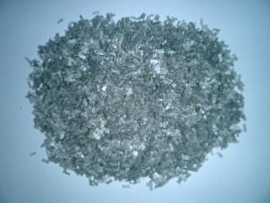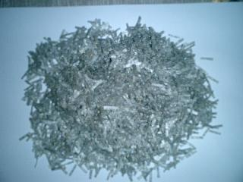

6.35 mm 12.70 mm

**Figure 1.** Samples of polyester fibers



**Figure 2.** Specification limits and selected gradation for wearing course

(12.5 mm nominal maximum aggregate size).

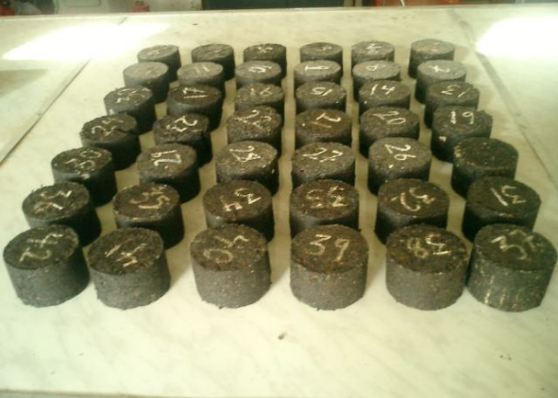

**Figure 3.**Marshall specimens.

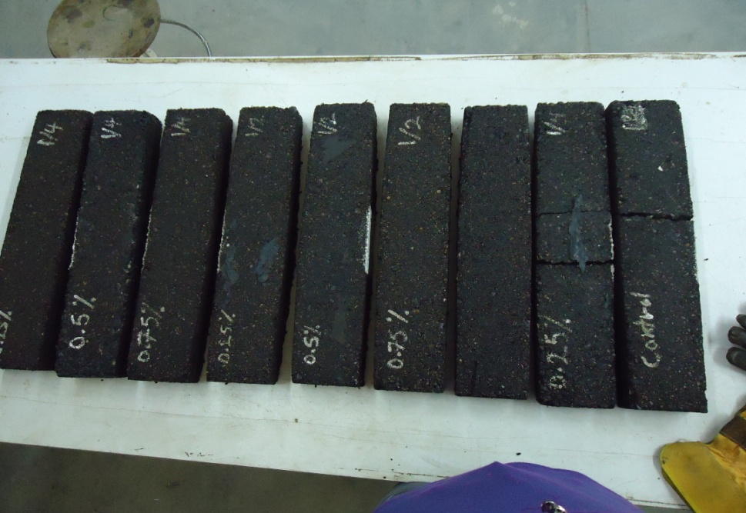

**Figure 4.**Asphalt beam specimens.



**Figure 5.**Diagrammatic view of third point loading system.

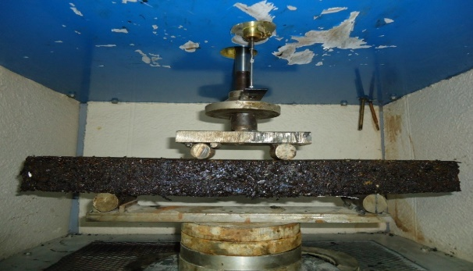

**Figure 6.**Flexural bending fatigue test.

|  |  |
| --- | --- |
|  |  |
|  |  |
|  |  |

**Figure 7.** Marshalltest results for control mixture.

**Figure 8.** Effect of fibers content on O.A.C

**Figure 9.** Effect of fibers content on Marshall stability.

**Figure 10.** Effect of fibers content on air voids .

**Figure 11.** Effect of fibers content on I.T.S .

**Figure 12.** Effect of fibers content on Nf .